DAY 2 ASSIGNMENT

ALGO TUTOR

(1)ER-DIAGRAM

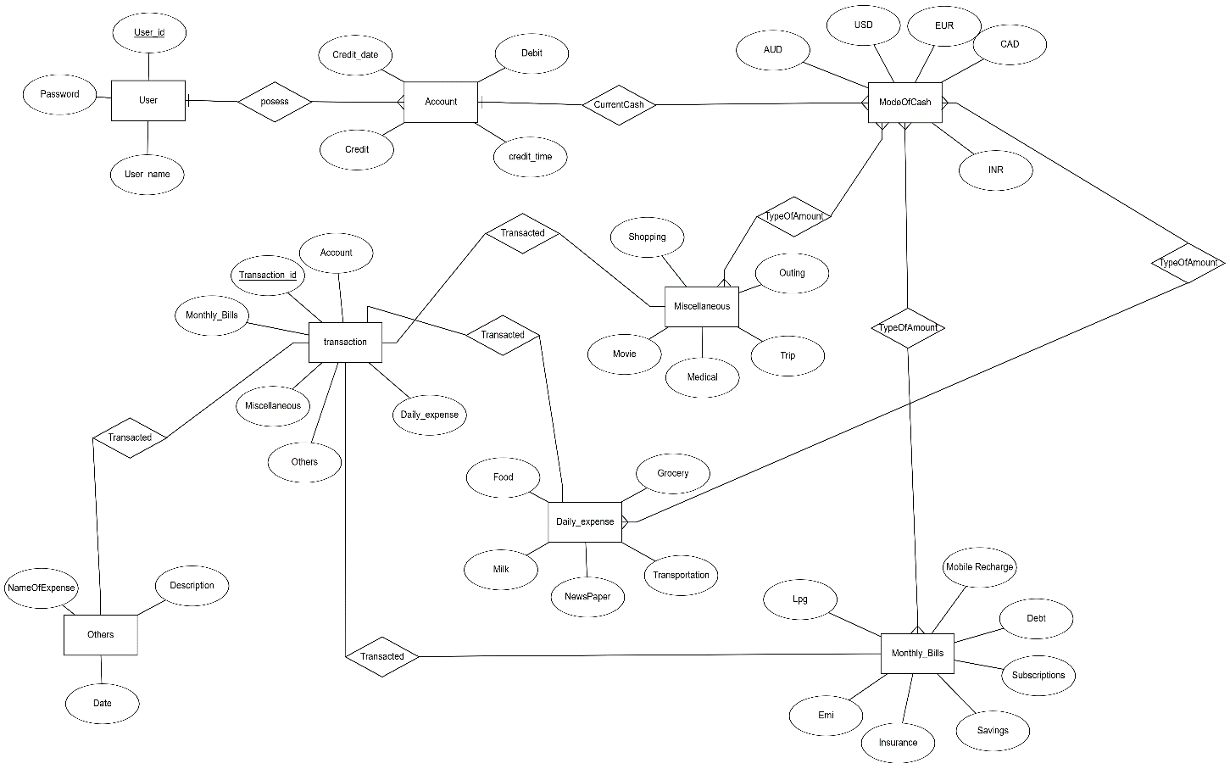

(2) CLASS DIAGRAM